**DEFENCE UNIVERSITY COLLEGE OF ENGINEERING**

**BISHOFTU**

**DEPARTMENT OF COMPUTER SCIENCE AND SYSTEM**

**ENGINEERING**



This Project documentation submitted in partial fulfillment of the requirements for the Degree of Bachelor Computer Science and System Engineering.

PREPARED BY:

* Birhanesh Zaza ………………………RDEG /102/10
* Eskedar Sisay………………………...RDEG/105/10
* Selamawit Melese …………………..RDEG/117/10
* Solomon Mekonnen…………………RDEG/119/10

ADVISORS: LT Sisay.B

Feb 2022

Computer Science and System Engineering Department Laboratory And Assessment Management system

This Project documentation submitted in partial fulfillment of the requirements for the Degree of Bachelor Computer Science and System Engineering.

Project Advised by: Sisay.B

Name and signature of Members of the examining board:

Name Title Signature Date

1. __________________ Advisor _____________ _____________

2. __________________ Chairperson _____________ _____________

3. __________________ Examiner _____________ _____________

4. __________________ Examiner _____________ _____________

5. __________________ Examiner _____________ _____________

Declaration of Originality

We declare that this project is our original work and has not been presented for a degree in any other university.

Name Signature Date

1. __________________ __________________

2. __________________ _________________

3. __________________ __________________

4. __________________ __________________

This project documentation has been submitted for examination with my approval as university advisor:

Advisor Name _________________________

# **ACKNOWLEDGMENT**

We would like to thank our almighty God who gives us the strength and allows us to this crucial time and also some people of Defence engineering collage especially our advisor LT.Sisay.B for giving us advice about this project and all-around tips about how the project should be done and Mr Esubalew for giving us advice before this project selected and what kind of project should we do and all-round as well as best advice.

# **ACRONYMS**

FYP Final Year Project

LAMS laboratory and Assessment Management System

PHP Hypertext Preprocessor

HTML Hyper Text Markup Language

CSS Cascading Style Sheets

MySQL structural query language

JSON JavaScript Object Notation

Vs code visual studio code

# **Abstract**

International Research Journal of Engineering and Technology (IRJET) e-ISSN: 2395-0056

Volume: 07 Issue: 02 | Feb 2020 www.irjet.net p-ISSN: 2395-0072

© 2020, IRJET | Impact Factor value: 7.34 | ISO 9001:2008 Certified Journal | Page 1356

Computer Laboratory Management System for Improving Teaching &

Learning Methods

Sejal Utekar1, Sonali Panda2, Tejas Khopade3, Kaustubh Manjarekar4, Lect. S. S. Patil5

1,2,3,4Student, Dept. of Computer Technology, B.V.J.N.I.O.T, Pune, Maharashtra, India.

5Lecturer, Dept. of Computer Technology, B.V.J.N.I.O.T, Pune, Maharashtra, India.

---------------------------------------------------------------------***----------------------------------------------------------------------

Abstract - Nowadays, many applications use online system to

interact with the user. It is because, it has many advantages

and helps in effective and efficient manner to interact with the

user. In today’s world application based study is more

important for each and every student, recognizing that

requirement the development of this systems idea came into

existence which will be helpful for teachers, students and

institute.

The purpose of this system is to develop LAN based control

system that can monitor the activities of terminal in computer

laboratory. The system will be based on student and teacher

module. With the help of proposed system teachers can assign

weekly assignments and can maintain the attendance of the

students. In student’s module, there will be deadline for

submissions of assignment that will be given by teachers.

Students have to follow the deadline and have to submit their

assignments. After submission of assignment teacher updates

the attendance of the students in teacher’s module. This system

will be beneficial for teachers which will minimize their

documentation as well as time. It will also help students to

concentrate and be more attentive towards practical work

and teacher will also able to solve their problems individually.

The laboratory and assessment management system can be accessed and used productively throughout the organization with the appropriate access permissions. This system can be used by the faculty of the college as a departmental management tool. the Lab management system that incorporates all the processes needed for effectively managing data both incoming and outgoing management information and The assessment system will be based on the student and teacher module. With the help of proposed system, teachers can assign weekly assignments and can maintain the attendance of the students. In student’s odule, there will be deadline for submissions of assignment that will be given by teachers. Students have to follow the deadline and have to submit their assignments. After submission of assignment teacher updates the attendance of the students in teacher’s module. This system will be beneficial or teachers which will minimize their documentation as well s time. It will also help students to concentrate and be more attentive towards practical work and teacher will also able to solve their problems individually.

Table of Contents

**ACKNOWLEDGMENT** 3

**ACRONYMS** 3

**Abstract** 4

**CHAPTER ONE** 7

**1. Introduction** 7

**1.1.Background** 7

**1.2. Statement of the problem** 8

**1.3. Objective of the project** 8

1.3.1. General Objective 8

**1.3.2. Specific Objective** 8

**1.4. Significance of the project** 9

**1.5. Beneficiaries of the project** 9

**1.6. Application area** 9

**1.7. Methodology** 10

1.7.1. Data collection methodology 10

1.7.2. Development Environment and programming tool 10

**1.7.3. Testing Procedure** 11

**1.8. Scope of the project** 12

**1.8. Risk, Assumption and Constraints** 12

1.8.1. Risk 12

**1.8.2. Assumptions** 13

**1.8.3. Constraints** 13

1.10. Feasibility study 14

**2.2.3. PHP** 18

2.3. Proposed System 20

2.4. Summary 21

4.2.1.1 Login 50

# **CHAPTER ONE**

## **1. Introduction**

## **1.1.Background**

“Defense Engineering College established in 1997, by Ministry of National Defense to produce highly professional and technically efficient military. The driving force for establishing DEC, among other things, was that Minster of National Defense did not have sufficient technical military personnel and that the higher institutions did not have programs compatible with the demands of Minster of National Defense. On its effort to achieve academic excellence, the college community goes through many days to day functions. In each department there are many students, teachers, assistants, staff members and leaders which are actively participating in the education tasks.”

A LAMS is a web based system. That can be used by the faculty of the college as a departmental management tool .the laboratory and assessment management system have the ability to manage a variety of student-related data requirements in a department. including assigning student , add all courses from 1st year up to 5th year , delivering assignment and mange Assessment also Full information of teachers like their studies, their status and their type . Also managing the laboratories in the department and keeping records of the materials. The Computer science and system engineering Department laboratory Management System is being created to meet all needs and specifications at the departmental level.

Users are people who engage with the system in some way. The user's web browser is the primary method of user engagement. The user will enter their email and password to access the system. Entry will be cancelled if the conditions are incorrect.

There are two user levels administrator level and user level . which has unique functionalities. It is a complete online project, for a firm to run it successfully. It is compulsory to take feedback from clients. The front-end will be HTML pages. Java code will be used for validation and processing of user input and database it will act as a middle layer. Third layer of database will be interacted with these layers, which would be MYSQL database. The web server would be Apache Tomcat.

## **1.2. Statement of the problem**

The problems regarding the current system in the departement were analyzed and noted. This project aims to solve some of the problems that faced the college due to traditional paper based system.

Such as:-

* Avoid physical counts
* High cost
* Time consuming
* Storage problems

# **1.3. Objective of the project**

## 1.3.1. General Objective

The general objective of Our project provides the ability to track managing the laboratories to keeping records of the materials and managing Assessment to upload and analyze assessment in the department. It reduces manual work.

## **1.3.2. Specific Objective**

The specific objectives of this project work are the following:

* To provides accurate information of the laboratory equipment.
* To improve the proper lab resource management.
* Attach any file online in order to remove any biased actions between teacher and student by favoring individuals to get extra class’s resource than the rest of the student.
* To reduce wastage of time for students and effort of teachers.
* To provides slightest work efficiently for student, teacher and lab assistance.

# **1.4. Significance of the project**

The development of this project is significant. Because the project allows teachers to save their golden time, to save the college resource for example paper work and etc... save time for Student to see their result of assignment, the system help us to be adapt digital world. Computer laboratory comprised of several computers that connected to a network which a network is consist of collection of computers and other equipment that is connected together to communicate with each other.

Other significance can be:

* The project minimizes all the manual approach of maintaining class information on paper by automating.
* Saves efforts and time and it is cost-effective.
* The computer laboratory time management system provides a centralized management for workstations, which are managed by the system administrator.
* The computer laboratory enables suitable time allocation to students based on demand for practical activities by allowing only authorized users with valid username and password to share the few available computer facilities.
* For university administrators will provide the school administrators the exact report of computer usage.

# **1.5. Beneficiaries of the project**

At the current stage of the project, those who benefited are DEFENCE UNIVERSTY COLLEGE OF ENGINEERING students and teachers

# **1.6. Application area**

At the beginning, the main users of this system are Defence university college of engineering‘s Students, and Teachers but the number of users will grow and encompass others who want to contribute for the community for future.

## **1.7. Methodology**

## 1.7.1. Data collection methodology

This project will use the following methodologies for the following different tasks: -

Interview

On job observation

Review of relevant documents

Review of similar platforms

## 1.7.2. Development Environment and programming tool

The following development environments and programming tools are selected based on the following criteria:

Primarily team members experience with the tools and Software.

By the rate given to the software’s in different sites.

The features that the tools have to make the project more effective.

**Tools**

Operating system:

Windows 10

Database:

MySQL

Back end:

PHP

Front end language:

HTML,

CSS,

JS

Bootstrap,

Server:

XAMPP

Text editor:

Vs code editor

MS word 2016- for all word processing tasks and documentations.

Visio 2016 to draw diagrams.

## **1.7.3. Testing Procedure**

**Software testing** is a process, to evaluate the functionality of a software application with an intent to find whether the developed software met the specified requirements or not and to identify the defects to ensure that the product is defect-free in order to produce a quality product.

We will conduct the following two tests: -

1. **Black Box Testing** treats the software as a” black box,” without any knowledge of internal implementation. Black box testing methods include : equivalence partitioning, boundary value analysis, all-pairs testing, fuzz testing, model-based testing, traceability matrix, exploratory testing and speciﬁcation-based testing.
2. **White Box Testing** by contrast to black box testing, is when the tester has access to the internal data structures and algorithms (and the code that implement these). White box testing methods can also be used to evaluate the completeness of a test suite that was created with black box testing methods. This allows the software team to examine parts of a system that are rarely tested and ensures that the most important function points have been tested.

This project is implemented using python with the Django framework. The code consists of models and views which can be tested. Models deﬁne the tables stored in SQL and the relationship between the diﬀerent tables using foreign keys. A view function, or “view” for short, is simply a Python function that takes a web request and returns a web response. This response can be the HTML contents of a Web page, or a redirect, or a 404 error, or an XML document, or an image, etc

In testing the functionality of the website, the following will be tested:

**Link test**

Internal Links

External Links

Broken Links

**Forms test**

Field validation

Error message for wrong input

Optional and Mandatory fields

**Session Test**

Session handling

**Database test**

Testing will be done on the database integrity

## **1.8. Scope of the project**

Laboratory and assessment management system is becoming a very essential component in education in this modern Day. With the help of College Automation System, we can gather all the useful information needed to the management in few clicks. The system now computerizes all the details that are maintained manually. Once the details are fed into the system or computer there is no need for various persons to deal with separate sections. At the current stage, the project is designed for student, teacher & Lab assistance interaction only.

## **1.8. Risk, Assumption and Constraints**

## 1.8.1. Risk

Risk Identification determines which risks might affect the project and documents their characteristics. A risk factor is a situation that may give rise to one or more project risks.

###### Table1-1­Risk table

|  |  |  |
| --- | --- | --- |
| Risk | Description | Mitigation |
| Risks | -To attain expected benefit from the project  -To estimate accurate project cost estimates  -To estimate accurate project duration | Understanding the users’ requirements very well will improve the benefits of the project,  To approach estimation for accuracies of the project cost and duration feasibility study is used. |

## **1.8.2. Assumptions**

Assumption is any project factor that is considered to be true, real, or certain without empirical proof or demonstration. Realistically speaking, it's impossible to plan a project without making a few assumptions.

## **1.8.3. Constraints**

Project constraints are anything that restricts or dictates the actions of the project team. That can cover a lot of territory. The triple constraints—time, resources, and quality are the big hitters, and every project has one or two, if not all three, of the triple constraints as a project driver. Many projects in the Information Technology area, for instance, are driven by time.

###### Table1-2 Constraints Table

|  |  |
| --- | --- |
| Assumption and Constraints | Description |
| Constraint | . Time spent in normal class, quiz preparation, class assignments, final exam preparation and other factors.  . Cost that can be used to help the project when the team members are working outside the campus which requires several cost such as for internet cafe |
| Assumptions | There will not be any internet interruption for long period of time or days.  There will be continues electric power source. |

**1.9. Project organization**

A project organization is a structure that facilitates the coordination and implementation of project activities. Its main reason is to create an environment that fosters interactions among the team members with a minimum amount of disruptions, overlaps and conflict.

 Figure1-1 Project organization detail work structure with the team members.

## 1.10. Feasibility study

As the name implies, a feasibility analysis is used to determine the viability of an idea, such as ensuring a project is legally and technically feasible as well as economically justifiable. It tells us whether a project is worth the investment in some cases, a project may not be doable. There can be many reasons for this, including requiring too many resources, which not only prevents those resources

**CHAPTER TWO**

**2. Literature Review**

**2.1. Introduction**

This chapter review different journals, papers, literature's written about effectiveness of using digital class system and as Development of systems needs a detailed and deep analysis and study of other systems which are similar to the platform that is going to be developed.

**2.2. Effectiveness of using Laboratory and Assessment management system**

In the current world, technology has changed the ways in which people learn. The main question does not lie upon whether a person should get laboratory and assessment management system learning or be offered with classes online, by what matters is the manner in which it is implemented. The proposed System Computer Laboratory Manage System is a LAN-based system which will further increase the efficiency of learning, management and. This system will benefit the instructor, lab assistance and the student, as it simplifies common tasks in a normal PC-based classroom. The server, which is used by the lab assistance as a control device for communicating, provides several functions: broadcasting laboratory work and announcement viewing and locking computer screens; and database reports. A system that would lessen the unmannered use of computers, time consuming of turning off all computers, get rid of using computers if not in a schedule.

Assessment management system reflect pedagogy, measure the application of both new knowledge and course objectives, as well as identify learning outcomes. Results within summative and formative assessments have been measured in the online learning environment as educators seek to meet objectives with respect to student success in the non-traditional setting. The purpose of reviewing this research is to present the goals, limitations, and recommendations associated with studies regarding classroom assessment management techniques and their effectiveness when implemented in the online setting. assessment techniques in the online environment are effective in measuring course outcomes. Included herein is a literature review of existing studies, which offer insight into a variety of online Assessment system techniques.

**2.2.1.** **Literature Review of other system**

**2.2.2*.* MySQL**

What is MySQL?

MySQL is a database management system that is used to maintain relational databases. It is an open-source software backed by Oracle Corporation. This was originally founded by a Swedish company called MYSQL AB which was later acquired by sun microsystems and finally is with Oracle Corporation. As it is an open-source database system, the source code can be modified according to our needs. It also offers premium services if a commercial license is purchased from Oracle Corporation. MySQL is a scalable, fast, and reliable database management system which can run on any platform like Windows, Unix, Linux, etc., and can be installed on the desktop or any server machine.

**Features of MYSQL**

* **Relational Database Management System (RDBMS):** **MySQL is easy to use. We have to get only the basic knowledge of SQL. We can build and interact with MySQL by using only a few simple SQL statements.**
* **Easy to use:** MySQL is easy to use. We have to get only the basic knowledge of SQL. We can build and interact with MySQL by using only a few simple SQL statements
* **It is secure:** MySQL consists of a solid data security layer that protects sensitive data from intruders. Also, passwords are encrypted in MySQL.
* **Client/ Server Architecture:** MySQL follows the working of a client/server architecture. There is a database server (MySQL) and arbitrarily many clients (application programs), which communicate with the server; that is, they can query data, save changes.
* **Free to download:** MySQL is free to use so that we can download it from MySQL official website without any cost.
* **Character Sets:** It supports different character sets, and this includes latin1 (cp1252 character encoding), German, Ujis, other Unicode character sets and so on.
* **Memory efficiency**: Its efficiency is high because it has a very low memory leakage problem.
* **Data Types:** It contains multiple data types such as unsigned integers, signed integers, float (FLOAT), double (DOUBLE), character (CHAR), variable character (VARCHAR), text, blob, date, time, date time, timestamp, year, and so on.
* **Partitioning:** This feature improves the performance and provides fast management of the large database.
* **Dual Password Support:** MySQL version 8.0 provides support for dual passwords: one is the current password, and another is a secondary password, which allows us to transition to the new password.

**Pros:**

* Data Security
* On-demand scalability
* High performance
* Round-the-clock uptime
* Comprehensive transactional support
* Complete workflow control
* Reduced total cost of ownership
* The flexibility of open source

**Cons:**

* MySQL does not support a very large database size as efficiently.
* MySQL does not support ROLE, COMMIT, and Stored procedures in versions less than 5.0.
* Transactions are not handled very efficiently.
* There are a few stability issues.
* It suffers from poor performance scaling.
* The development is not community driven so it has lagged behind.
* The functionality tends to be heavily dependent on the add-ons.
* Developers may find some of its limitations very frustrating.

### **2.2.3. PHP**

PHP is a script on the server-side used for the creation of Static or Dynamic Web sites or Web applications. PHP is a pre-processor for hypertext, which used to stand for home pages. The software used to build web applications is an open-source, server-side scripting language. We say a program designed for automated work by writing a script-based language (code lines). It is suitable for the output and construction of dynamic web pages for web applications, e-commerce applications, and database applications. PHP can be inserted into HTML.

Whenever you type in a URL or request by clicking on any link (which again is nothing but indirectly supplying an URL,) the request is forwarded by your web browser (Firefox, Chrome, etc.) over the internet to a ‘server’. Now this server is where all the pages you code for are actually stored. Also, all the user accounts will obviously be present on the server. Now think about this: applications like Facebook, emails, etc., will have lots of user accounts, right? So managing such data is a little tricky. Hence computer programmers have come up with something called “databases”. These help in efficiently handling (usually large amounts of) data, especially when it’s something that can be tabulated.

So, when the request hits the server, the server processes the requests and responds with the data (as a plane response or embedded inside a webpage). For these purposes, it is used. Basically, it is a server-side scripting language. Currently, Version PHP7 is the latest version.

**Pros:**

* Graceful maintenance operations, with no additional cost other than what will be spent for owning the database management systems itself.
* Supports and acts flexible for majority of the commonly used file formats, which comes in handy for documentation purposes while working on the database management systems.
* Separate panels for database manipulation, SQL query editing, status tracking, etc.
* Assists in displaying all the active plugins from the connected databases.
* **Web Based** − Being web based, phpMyAdmin UI is accessible using Web Browser and this interface is available on all the platforms where a web browser can work.
* **Multi-Server-** phpMyAdmin allows to operate multiple servers at a time.
* **Backup formats -**phpMyAdmin allows to take database backups in various formats like XML, CSV, SQL, PDF, OpenDocument Text, Excel, Word, and Spreadsheet, etc.
* **Graphical Interface** -phpMyAdmin provides graphical interface to run SQL commands and do SQL operations and makes it quite easy to use as compared to console based sql editors.

**Cons:**

* It cannot be used for any and all databases, as it supports only MySQL and Maria DB.
* Though it supports the classic servers and systems, its growth is not parallel to the technological growth of the current industry standards.
* **Difficult Installation** − phpMyAdmin installation is not straight forward. User needs to install Apache Web Server, PHP and MySQL and then configure each soft wares separately. As an alternate solution is to use XAMPP, which bundles them as a package and have phpMyAdmin module as well. In case of fresh installation, XAMPP is the best choice to install WAMP/LAMP stack to use phpMyAdmin.
* **No schema visualization** − schema visualization capability is not present in phpMyAdmin.
* **No auto-compilation** − Auto-compilation functionality is not available as well.
* **No scheduled backup** − Automatic backup scheduling is not feasible.
* **No Encryption** − phpMyAdmin exports database in common text files thus needs high storage and poor security.

### 2.3. Proposed System

The proposed system has basically three types of user which have different privilege and role. Teacher, Lab Assistance, Student, and Admin. We have developed a system in which student can interact with their respective instructors digitally through our system. The system also provides a platform for any announcement that was found on the Notice Board. during the manual approach that required to go directly to the teacher office. Other advantage of the proposed system includes:

* User friendly interface
* Fast access to database
* Less error
* More Storage Capacity
* Look and Feel Environment
* Smooth interaction

### 2.4. Summary

In general, we have reviewed some related published journals on the effectiveness of implementing Laboratory and Assessment management system over the traditional (manual) one. The studies also show that the Laboratory and Assessment management system has the potential to improve engagement, to provide depth class resources, saves teacher and assistance ‘s time, etc.

**Chapter Three**

**System analysis and design**

Introduction

This section elaborates on the laboratory and assessment management system analysis and design. Models and diagrams in this chapter simply show the operational context of our system and architectural model of how the system interacts with actors or the sequence of activities in the lab and assessment management system.

**System modeling**

Modeling this system is the process of developing abstract models of a lab and assessment management system, with each model presenting a different view or perspective of that system.

System modeling has now come to mean representing a system using some kind of graphical notation, which is now almost always based on notations in the Unified Modeling Language (UML).

System modelling helps the analyst to understand the functionality of the system and models are used to communicate with end users.

**Laboratory and assessment management system Use case model**

This diagrams, which show the interactions between a system and its actor or how a person who actually uses that process or system will accomplish a goal.

The four basic elements used to design use case model are

* Actors
* System
* Use Cases
* Relationships between actors and use cases

**Actors:** The users that interact with a system. An actor can be a person, an organization, or an outside system that interacts with our application or system. They must be external objects that interact or use data.

**System:** A specific sequence of actions and interactions between actors and the system. A system may also be referred to as a scenario.

**Use cases**: Horizontally shaped ovals that represent the different uses that a user might have in our system.

**Relationship: A** line between actors and use cases.

Following are actor in this system

1. Admin
2. Student
3. Teacher
4. Lab assistant

The following use case are identified in our system

* UC_01 Login
* UC_02 Upload Assignment
* UC_03 add user
* UC_04 issue device
* UC_05 view lab equipment
* UC_06 See device status
* UC_07 borrow device
* UC_08 submit Assignment
* UC_9 add new device
* UC_10 Update account

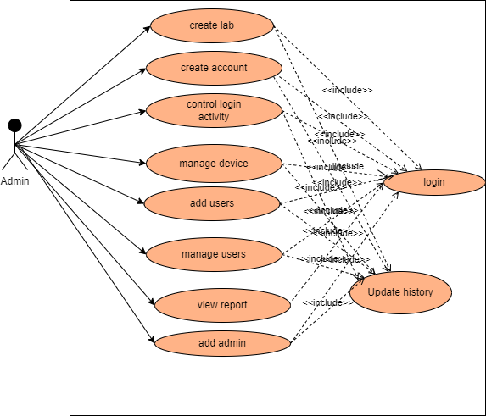

**Figure3-1 Use Case model for Admin**

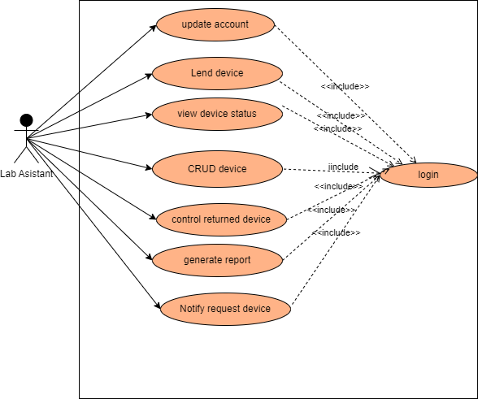

**Figure3-2 Use Case model for Lab assistant**

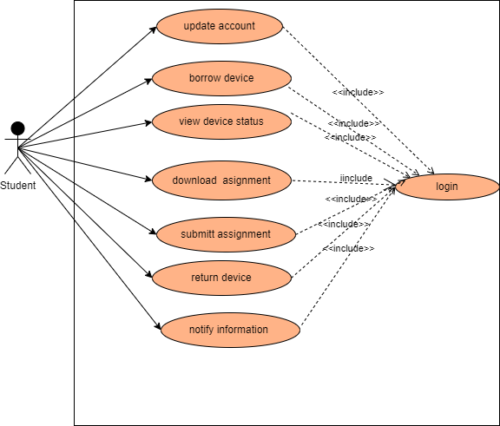

**Figure3-3 Use Case model for Student**

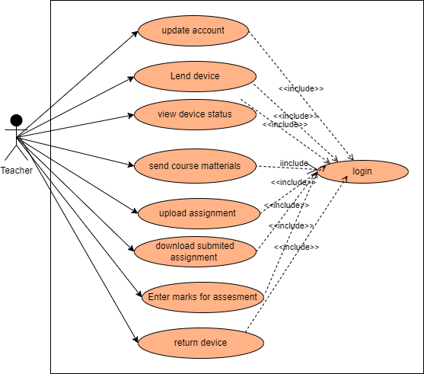

**Figure3-4 Use Case model for Teacher**

s

Table3-1 Use case description for Login

|  |  |
| --- | --- |
| Use case name | Login |
| Number | UC_01 |
| Description | This use case is used by Admin, Techer, Lab assistant and Student to log in to the system according to their privilege. |
| Participating actor | Admin, Teacher, Lab assistant, student |
| Precondition | * Admin must have an internet access. * The admin must have create User Name, email and password for each user then initially all other user use this account to access the system and they can change their user name and password after logged in to the system. |
| Flow events | 1. Admin create account for each user. 2. Each actor take their email and password from admin. 3. Actors browse the system using any browser. 4. System displays login form 5. Each actor enter their email and password to the login form. 6. Send in to the database by pressing login button. 7. The system authenticates the User Name and password. 8. The system redirects to the authorized page according to the privilege specified in the database and displays Dashboard based on their privilege. 9. End-use case |
| Post condition | The system should display to Admin, student, lab assistant or Teacher page |
| Alternative flow of events | If any incorrect user Name or password displays an error message.  Go back to login form |

Table3-2 Use case description for Assignment

|  |  |
| --- | --- |
| Use case name | Upload Assignment |
| Number | UC_02 |
| Description | Teacher Upload Assignment |
| Participating actor | Teacher |
| Precondition | * Admin must have an internet access * The Teacher must enter User Name and password to access the system. |
| Normal flow of events | 1. Teacher selects dashboard link.  2. Selects the Upload Assignment link.  3. Teacher select Assignment  4. Then teacher choose a file to be uploaded  5. Click upload button.  6. The system displays user assignment is uploaded successfully message.  End of use case. |
| Post condition | The Assignment is uploaded and Student can download the Assignment  And teacher can visit the uploaded assignment |
| Alternative flow of events | If any kind of error occurs while uploading the system redirects to the upload form |

Table3-3 Use case description for Add user

|  |  |
| --- | --- |
| Use case name | Add user |
| Use case number | Uc_03 |
| Use case description | Admin create account for each user according to their privilege |
| Participating actor | Admin |
| Pre-conditions | * Admin must have an account that created by developer or another admin * Admin must have an internet access |
| Flow of events | 1. Admin browses to the system. 2. Admin click add user link. 3. Add new user page displayed 4. Admin fill the form 5. Admin save the form to the database 6. System check validation 7. Data stored in to database |
| Post condition | User data fetched from database and visited by admin |
| Alternate flow of events | * If the validation is error while entering data error message displayed * System stayed on current page. |

Table3-4 Use case description for issue device

|  |  |
| --- | --- |
| Use case name | issue device |
| Use case number | Uc_04 |
| Use case description | The laboratory assistant issue device if the device is available by referring device status in the device table |
| Participating actor | Laboratory Assistant. |
| Pre-conditions | * Laboratory assistant must have an account created by the admin * Laboratory assistant must have an internet access |
| Flow of events | 1. Laboratory Assistant browses the system. 2. Laboratory Assistant view issue request 3. If the device status in the device table is available and the user is authenticated click approve button 4. Laboratory assistant fills out the approved form. 5. Laboratory assistant approves the form for the database 6. Data stored in the database |
| Postcondition | Student view the request page issue date and return date |
| The alternate flow of events | * If the approval is not approved by the laboratory assistant the page stays on the previous status meaning the issue date and the return date is not fill. * System stayed on current page. |

Table3-5 Use case description for view lab equipment

|  |  |
| --- | --- |
| Use case name | view lab equipment |
| Use case number | Uc_05 |
| Use case description | * All actors view lab equipment status, quantity, and other detailed information about the device * But Laboratory assistants can register, update, delete and borrow the device if necessary. |
| Participating actor | All actors |
| Pre-conditions | * All actors must have an account to view lab equipment. * All actors must have an internet access |
| Flow of events | 1. All actors browse the system. 2. All actors view all lab equipment 3. All users can send issue requests to the lab assistant to borrow the device. 4. Laboratory Assistant adds, updates, deletes and borrows a device for the authenticated user. 5. Data stored in the database |
| Postcondition | Users view the request page issue date and return date if they send an issue request |
| The alternate flow of events | * If the approval is not approved by the laboratory assistant the page stays on the previous status meaning the issue date and the return date is not fill. * System stayed on current page. |

Table3-6 Use case description for see device status

|  |  |
| --- | --- |
| Use case name | See device status |
| Use case number | Uc_06 |
| Use case description | * All actors view lab equipment status detailed information about the device |
| Participating actor | All actors |
| Pre-conditions | * All actors must have an account to view device status. * All actors must have an internet access |
| Flow of events | 1. All actors browse the system 2. Users can ask request if the status is available in device status 3. But Laboratory assistants can borrow if the status is available 4. Data stored in the database |
| Postcondition | If the device status is available in device information user can send request to the laboratory assistant and if users cannot see the status of the device and the status is not available laboratory assistant also check the status if not available |
| The alternate flow of events | * If the status is not available the request is not approved since the status is available |

Table3-7 Use case description for borrow device

|  |  |
| --- | --- |
| Use case name | borrow device |
| Use case number | Uc_07 |
| Use case description | * Teachers and students can send requests and then borrow the device if the device is available |
| Participating actor | All actors |
| Pre-conditions | * All actors must have an account to borrow devices in the department. * All actors must have an internet access |
| Flow of events | 1. All actors browse the system 2. Users can ask request if the status is available in the device status 3. But Laboratory assistants can borrow if the status is available 4. Data stored in the database |
| Postcondition | * Borrow the device and return the device between the return date. unless expired. |
| The alternate flow of events | * If the user is not authorized the request is not approve. |

Table3-1 Use case description for Submit Assignment

|  |  |
| --- | --- |
| Use case name | Submit Assignment |
| Use case number | Uc_08 |
| Use case description | * Teachers can send Assessment for the students and then student download the assignment send by the teacher if the assignment is available |
| Participating actor | Student and teachers |
| Pre-conditions | * Both actors must have an account to send assessment and to submit assignment. * both actors must have an internet access |
| Flow of events | 1. both actors browse the system to send assessment and te view assignment. 2. Teachers must send assessment for the specific group of students. 3. Students check the new assignment page if there is new assignment 4. If student get new assignment from teachers the student submit assignment on assignment submission data unless submit button is disabled. |
| Postcondition | * If assignment is submitted on be for submission last date the assignment is submitted. Else assignment is not submitted. |
| The alternate flow of events | * Report the reason why the assignment is not submitted for the teacher. |

Table3-9 Use case description for Add new or unregistered device

|  |  |
| --- | --- |
| Use case name | Add new or unregistered device |
| Use case number | Uc_09 |
| Use case description | The laboratory assistant add device if the device is new or unregistered |
| Participating actor | Laboratory Assistant. |
| Pre-conditions | * Laboratory assistant must have an account created by the admin * Laboratory assistant must have an internet access |
| Flow of events | 1. Laboratory Assistant browses the system. 2. Laboratory Assistant add now device or unregistered device. 3. Laboratory assistant fills out the add device form. 4. Laboratory assistant insert the form for the database 5. Data stored in the database |
| Postcondition | After all forms are fill to register device, the registered device fetch to the device table automatically |
| The alternate flow of events | * If not, device register form fills correctly stayed on device registered page |

Table3-1 Use case description for update account

|  |  |
| --- | --- |
| Use case name | Update account |
| Use case number | Uc_10 |
| Use case description | All actors update their account like password, specialization, year and so on  But some attributes not updated like first name, last name, student group, session so on |
| Participating actor | All actors |
| Pre-conditions | * All actors must have an account created by the admin * All actors must have an internet access |
| Flow of events | 1. All actors browse the system. 2. All actors update their account. Like password and specialization. When updating their password, the old password must be entered first after this the new password and coniform new password must be the same to update the old password. 3. The updated Data stored in the database |
| Post-condition | After data is updated, the previous data is removed and the updated data is stored |
| The alternate flow of events | * If not updated stayed on the previous data. |

3.4.4. Sequence Diagram

Sequence Diagrams are interaction diagrams that detail how operations are carried out. They capture the interaction between objects in the context of a collaboration. Sequence Diagrams are time focus and they show the order of the interaction visually by using the vertical axis of the diagram to represent time what messages are sent and when.

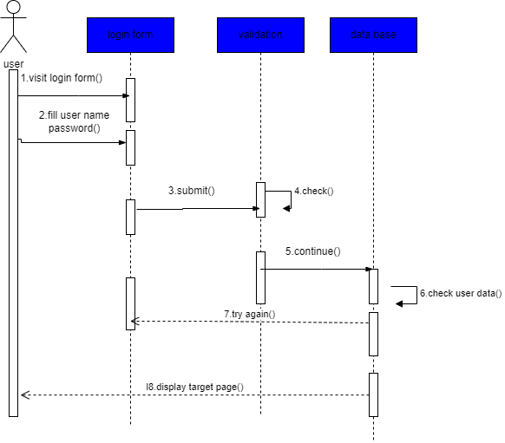

**Fig 3-4 sequence diagram for login**

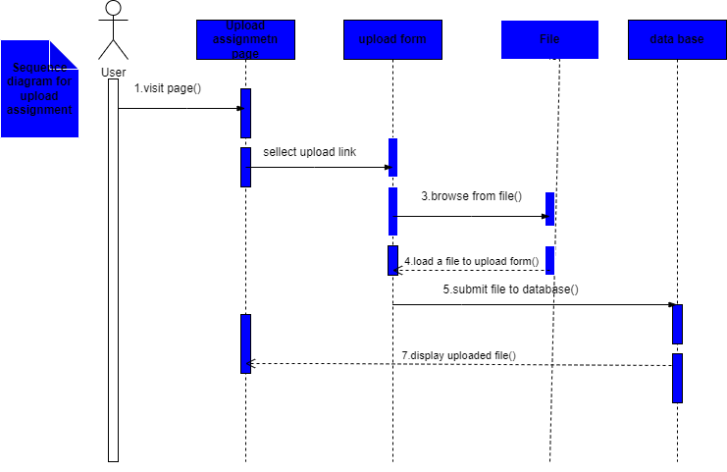

**Fig 3-5 sequence diagram for upload assignment**

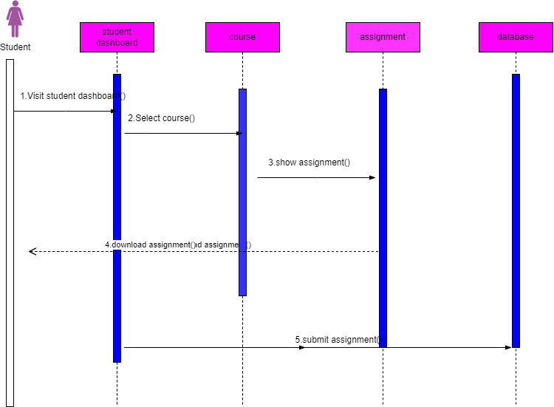

**Fig -3-5 sequence diagram for student**

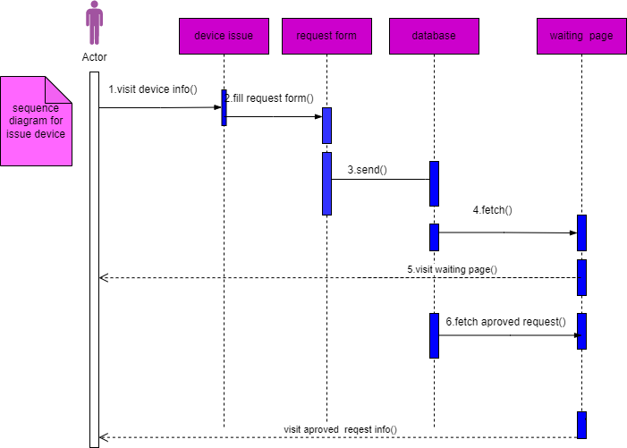

**Fig 3-6 sequence diagram for issue device**

**3.4.5. Activity diagram**

Activity Diagram is a behavioral diagram i.e. it depicts the behavior of a system. An activity diagram portrays the control flow from a start point to a finish point showing the various decision paths that exist while the activity is being executed.

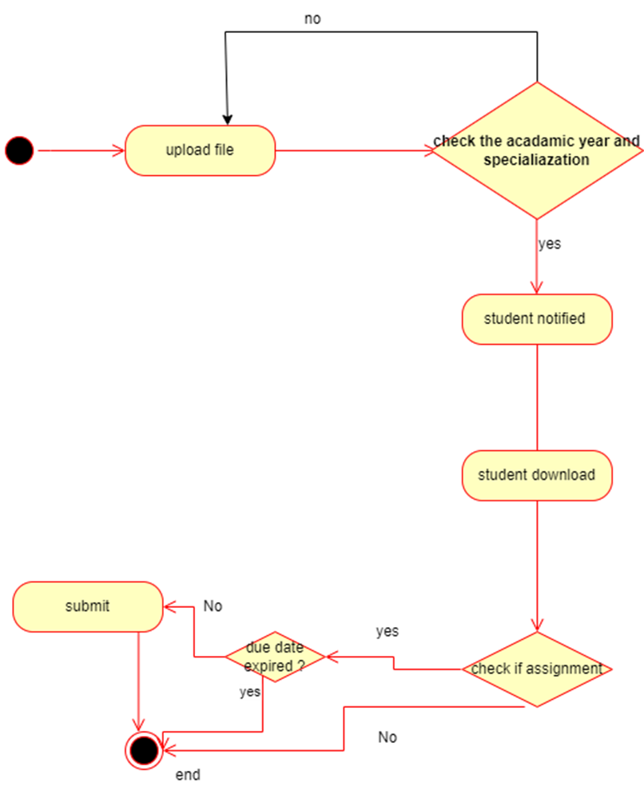

**Fig 3-7 activity diagram for assessment**

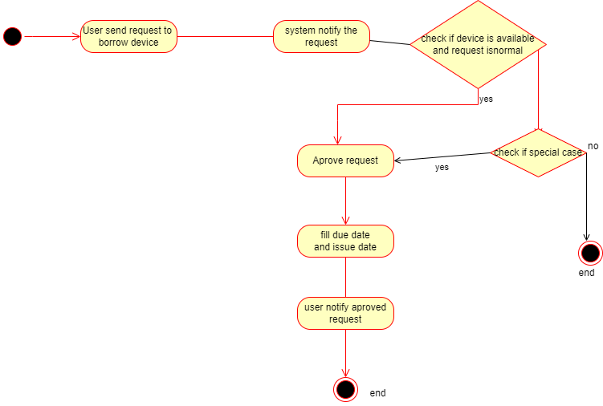

**Fig -3-8 Activity diagram issue device**

**3.4.6. Class diagram**

Class diagram is a static diagram. It represents the static view of an application. Class diagram is not only used for visualizing, describing, and documenting different aspects of a system but also for constructing executable code of the software application. Class diagram describes the attributes and operations of a class and also the constraints imposed on the system.

**3.4.7. Purpose of Class Diagrams**

Class diagrams are the most important kind of UML diagram and are vitally important in software development. Class diagrams are the best way to illustrate a system’s structure in a detailed way, showing its attributes, operations as well as its inter-relationships.

**3.4.8. Deployment**

Deployment Diagram is a type of diagram that specifies the physical hardware on which the software system will execute. It also determines how the software is deployed on the underlying hardware. It maps software pieces of a system to the device that are going to execute it.

**3.4.8.1. Purpose of Deployment Diagrams**

Deployment diagrams are used with the sole purpose of describing how software is deployed into the hardware system. It visualizes how software interacts with the hardware to execute the complete functionality. It is used to describe software to hardware interaction and vice versa.



**Figure3-12 Deployment diagram**

##### CHAPTER FOUR

##### 4. System Description

##### 4.1. Introductions

The new proposed system named ‘DUCoE Laboratory and Assessment Management System’ is a computer-based web application which digitizes the laboratory *equipment* and assessment system.

The system provides:

* Each teacher will be able to insert assessments and enter marks for their respective students.
* Each student will be able to view the device status to send a request.
* Each student will be able to view the assignment’s due date to submit their assignment before the due date is passed.
* Each teacher will be able to view the device status to send a request for the laboratory assistant.
* The laboratory assistant will have access to view requests sent from students and teachers where they are sent requests unless the system says there is no pending request.
* The administrator will be able to add and update information such as teachers, lab assistants, students, and courses.
* The administrator is able to see all activity in the system from the activity log page.

This section of the document is aimed to describe the proposed system and its major functions in detail. The section also provides major navigation pages with their corresponding outputs and layouts in the preferred format and describes the system architecture including the database, the server, and the front-end framework.

##### 4.1.1. Essential Navigations

‘DUCoE Laboratory and Assessment Management System’ is a computer-based system and has multiple pages navigated by the user. In general, there are four main pages, namely

* **Student page**: where they can view the device status of the equipment registered in the laboratory, view the Marks of the assignment to which they are submitted, and so on.

Students are end users of this system. The assessment is uploaded by the teachers and the device status is viewed by students. It helps them save time asking for requests to borrow devices and do assessment work manually.

* **Laboratory assistant page**: where they can add the devices into the system and view the device requests sent from students and teachers. if the request is sent from the user ab assistant can approve the request by checking the device status and quantity. unless the request page says there is no pending request. And also lab assistant can view the device issue information and return date expired information on the system.
* **Teacher page**: where will have access to information regarding the status of the device, and will also have an access to information on students who belong to the same session, year or Bache, specialization, and student group. Teachers and lab assistants are the key stakeholders of this system. Because they are the one who manages, edit, and updates the contents of the database of students such as assessments, devices, etc.
* **Administrator page**: where they can Add and Update students, teachers, lab assistants, courses, and notices. They will have the privilege to modify the database i.e., to add/remove students, teachers, lab assistants, and courses, and notice updated information regarding each of these. It is their responsibility to maintain the database. So the Administrator plays a major role in the system.

##### 4.2. Users page

##### 4.2.1 Admin page

## 4.2.1.1 Login

Admin in the department is assigned a unique email and password by the developer. The Admin may change the password later.

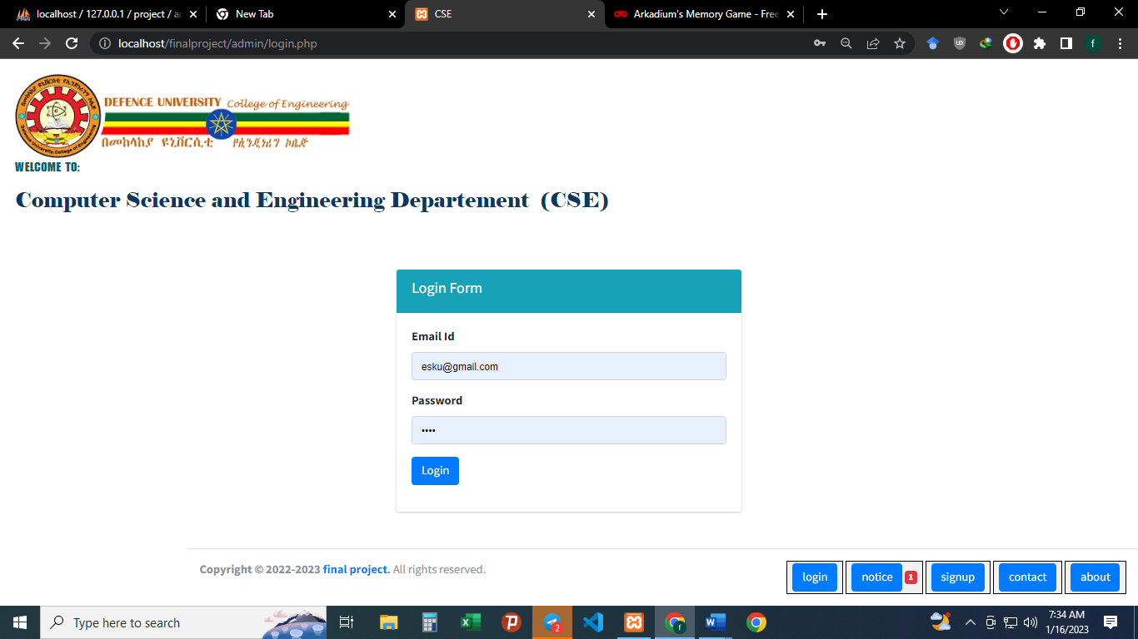

**Figure4.1 Student Login Page**

**4.2.1.2 Home page**

After successful login, the admin presented a homepage with their main sections, add a notice for all users who tries to interact with the system because the notice posts publicly. admin can view what is going on with the lab device list.

The administrator is responsible for adding and maintaining all the departments, students, teachers, lab assistants, and courses. All this data is stored in the database in their respective tables. This information is stored in the Assign table. View all activity in the system using the activity log.

There are several features in place to ensure that querying the database is quick and eﬃcient for the administrator. As the database has the potential to become huge, there is a search feature for every table including student, teacher, etc. The search has gotten a speciﬁc record based on all things as we went. Also, it can ﬁlter the record based on the user inter the search bar.

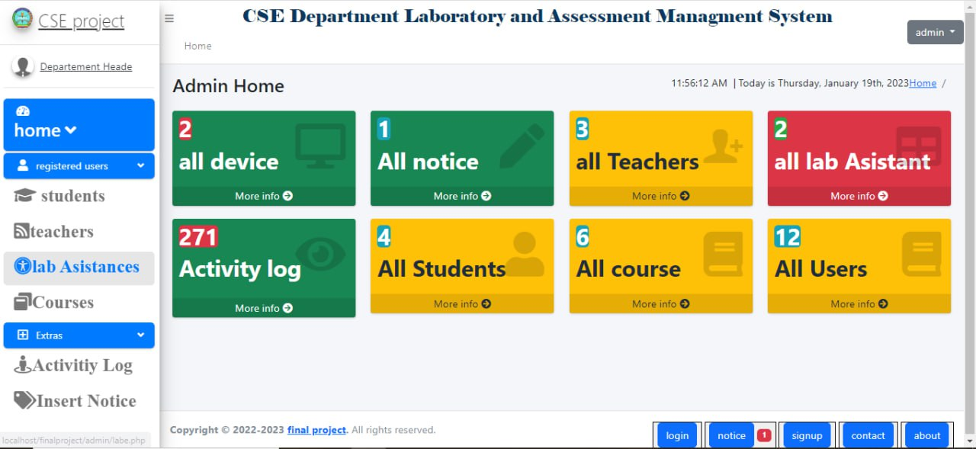

**Figure4.2 Admin Home Page**

**4.2.3.3 add student**

On this page, the admin add a student. Using modal or popup modal admin can add student by filling the student registration form correctly and press save button then the data displayed in the tabular form. admin also can delete and update the registered student records።

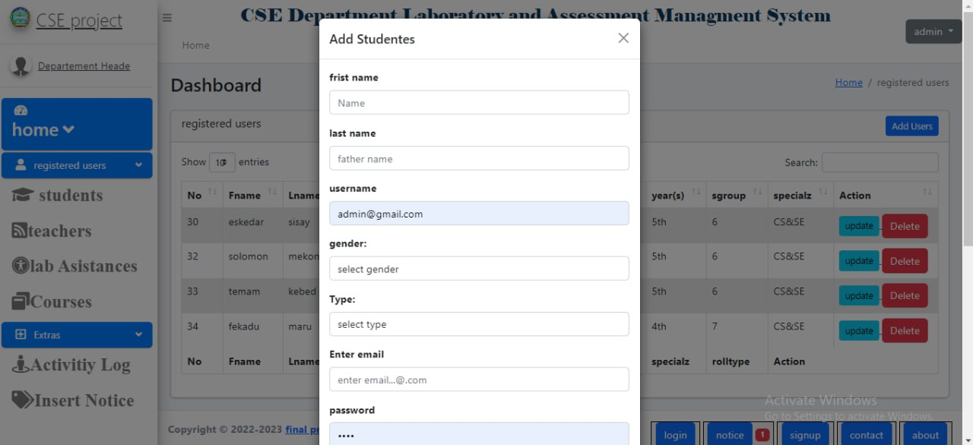

**Figure4.3 Admin student add Home Page**

**4.2.3.4 add course**

On this page, the admin add course. Using modal or popup modal admin can add course by filling the course registration form correctly and press save button then the data displayed in the tabular form. admin also can and update the registered course records.

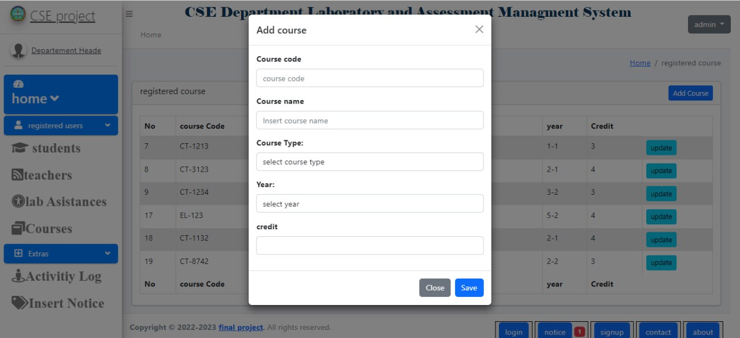

**Figure4.3 Admin course add Home Page**

**4.2.3.4 Activity log**

On this page, the admin view all activity in the system. In this activity log page when system user add, update, delete, borrow, and returned etc. anything the user can do in the system is registered users user name, date, and actions on activity log and displayed them on the admin activity log page.

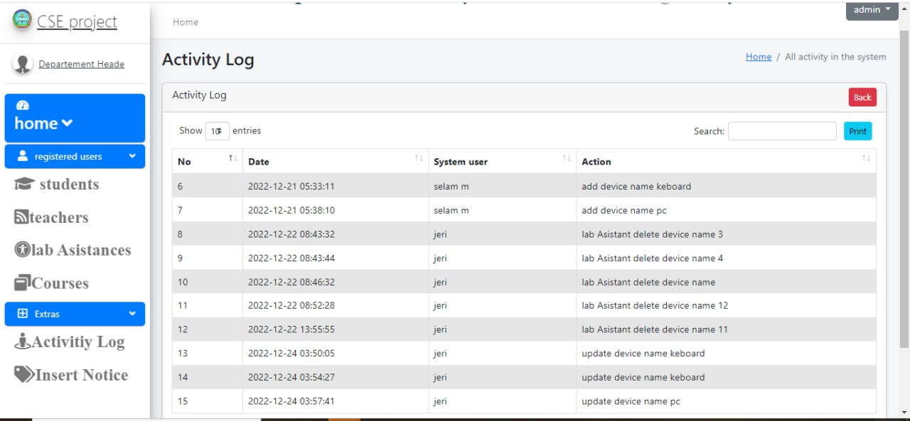

##### 4.2.2 Student page

**4.2.2.1 Login**

All student in the CSE Department is assigned a unique email and password by the administrator. They may change it later according to their wish.



**Figure4.1 Student Login Page**

**4.2.2.2 Home page**

After successful login, the student is presented a homepage with their main sections, new assignment, registered device, request, submitted assignment, change password. In the new assignment section the student can view their new assignment. In the registered device section, the student can view all devices registered by the lab assistant for each of their locations. in the request section, the student can view the request status whether approved or not in a tabular form. in the assignment section, the student can see assignments uploaded and submit that assignments to their teacher. In the profile section, each student can edit their assignment. in the submitted assignment section student see their marks only if the teacher inserts a mark for the assignment submitted by students.

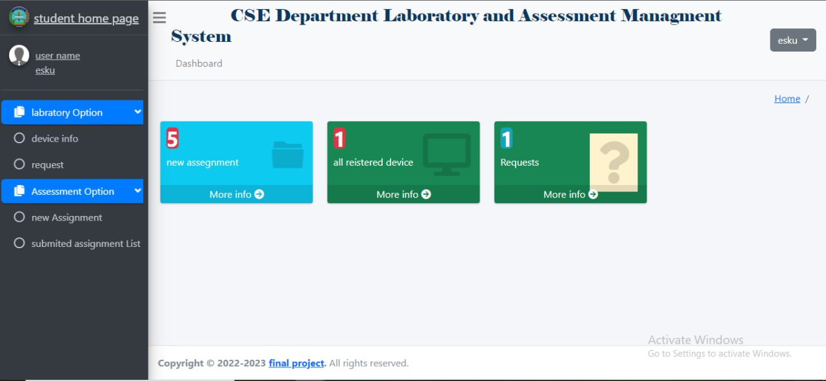

**Figure4.2 Student Home Page**

**4.2.2.3 new Assignment**

On the new assignment page, there is a list of assignment that is dependent on each course. For each assignment, the course name and teacher name are display along with the new assignment. If the new assignment’s due date is expired the student can’t submit the assignment. The submit button is color red and says Time out, otherwise submit button is active and it is green. If you click on submit button the page redirects to submit assignment page. on this page, the assignment name is fetched from the assessment. and the student can mansion the title of the assignment and upload the assignment to the teacher. Once the last date is less than now and the assignment is submitted to the teacher, a student can’t update it.

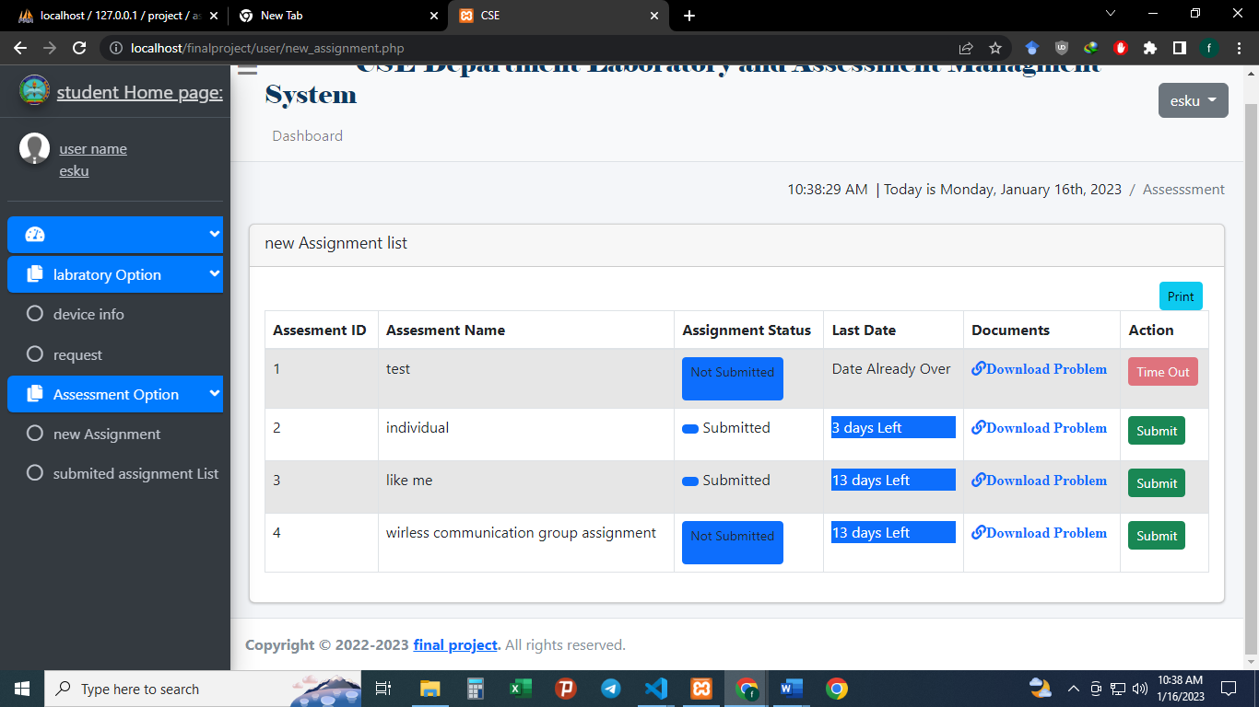

##### 

**Figure4.3 Student new assignment Page**

**4.2.2.4 submitted assignment**

The submitted assignment page is a table with the result Column an entry for each of their assignment. The result are speciﬁed along the works obtained in each of the assignments. On this submitted assignment page the student can view and resubmit the assignment if the last date is greater than now. Unless the submit button is disabled and says Time out.

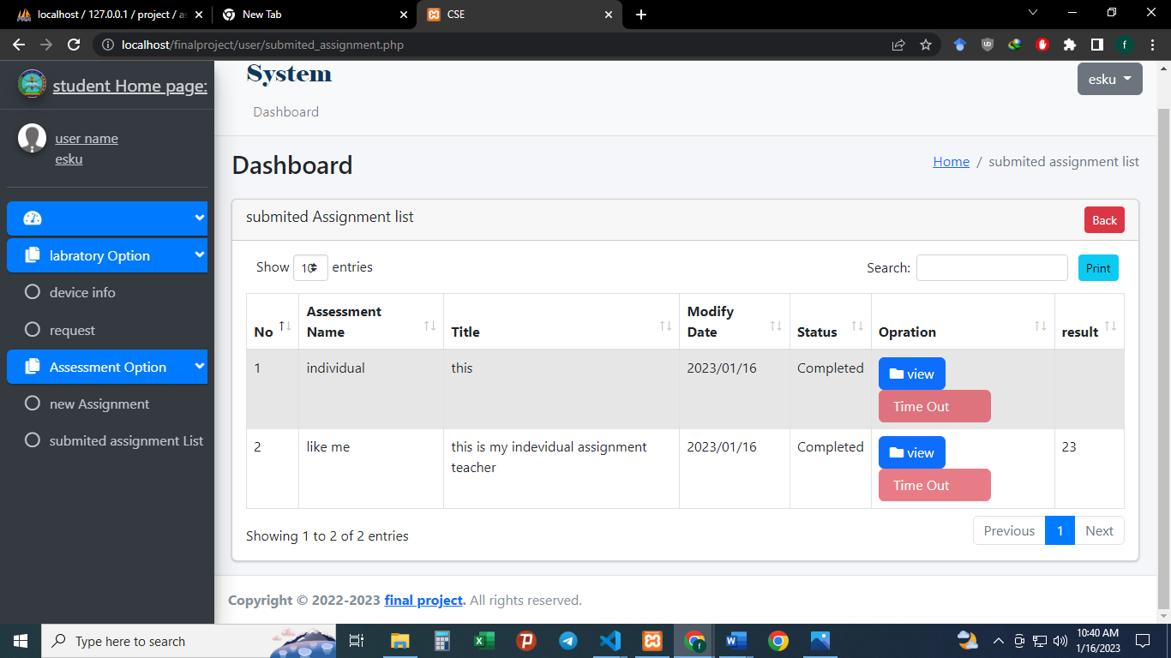

**Figure4.4 Student Submitted assignment Page**

##### 4.2.2.5 Send Request

This page is a table which lists the device registered in the system and request modal to send request by interring the device Did if the device status is available.

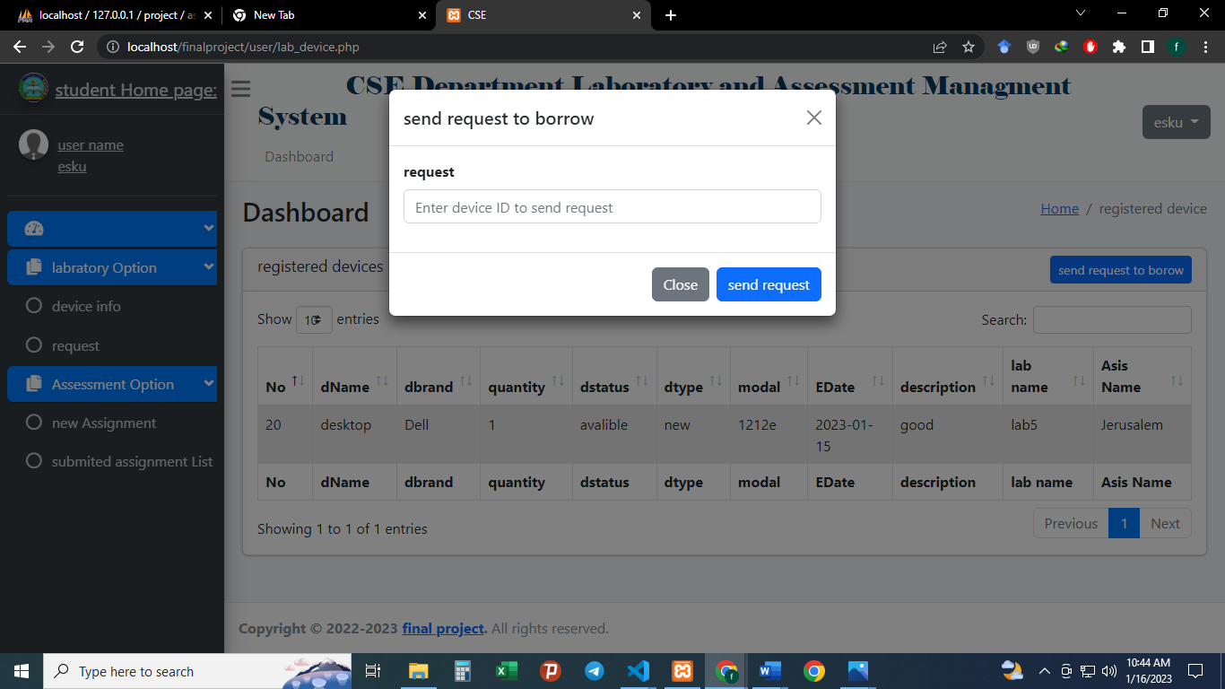

**Figure4.5 Student sending Request page**

**4.2.2.6 Request**

On this student request page, there is device id , approve status, issue date , and return date that control the device borrowed status. If there is no sending request to the lab assistant to borrow the device the page displays there is no pending request.

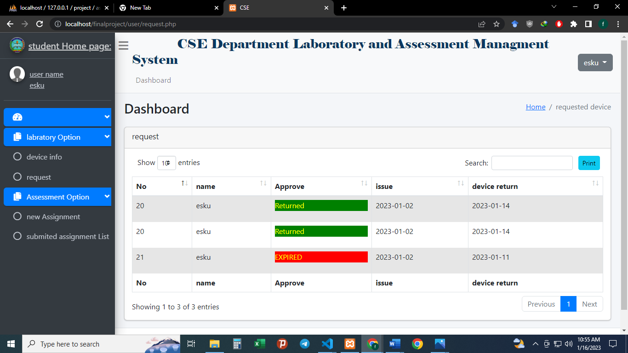

**Figure4.6 student Request**

**4.2.2.8 Students Change password**

This page helps student to create their own password. Before you change password you will need to have your current password**.**

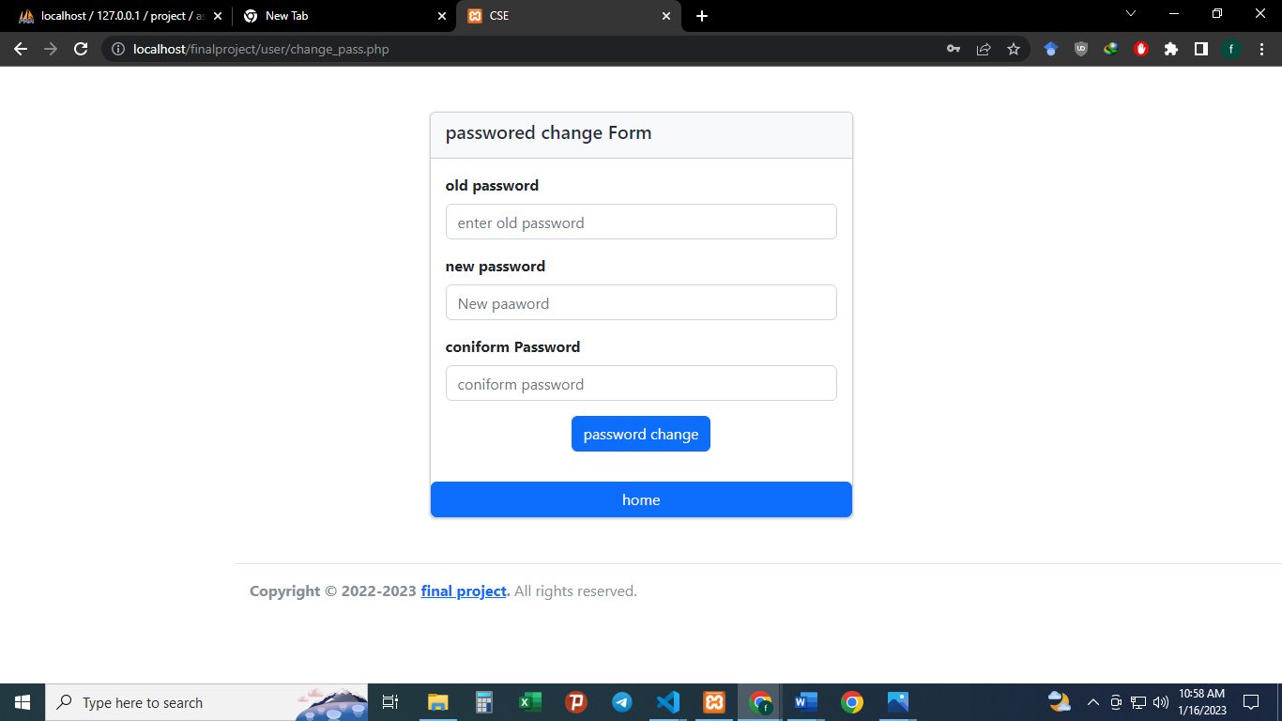

**Figure4.8 student Change password page**

##### 4.2.3 Teacher page

**4.2.3.1 Login**

Each teacher in the department is assigned a unique email and password by the administrator. The teacher may change the password later.

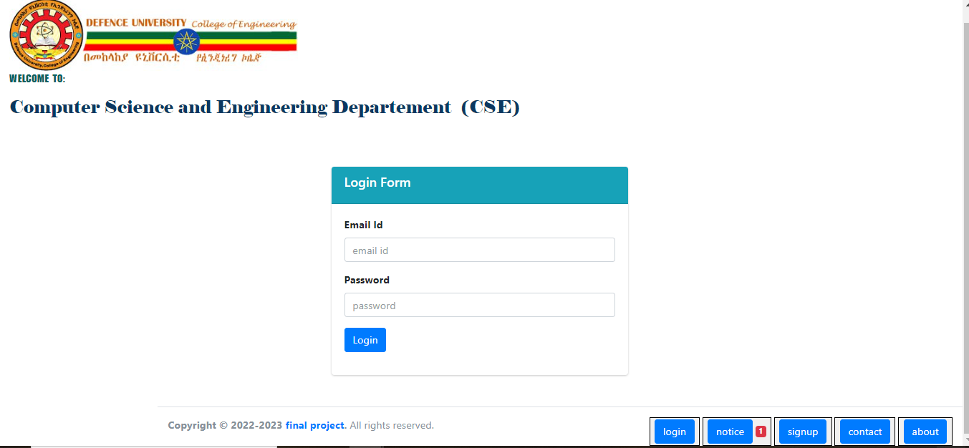

**Figure4.9 Teacher login page**

**4.2.3.2 Homepage**

After successful login, the teacher is presented a homepage with their main sections, add assignment, assessment list, submitted assignment, sent Request, change password, and give an individual mark for the submitted assignment. In the add assignment section, the teacher can enter the assessment of their respective students. In the assessment list section, the teacher may view the assessment. In the submitted assignment section the teacher can view and give marks for the submitted assignment for each student. In the request section, the teacher can send a request to borrow a device registered in the system. in changing password section, Teachers can change the password, the current password is necessary and the new password must be the same as the coniform password to change the password.

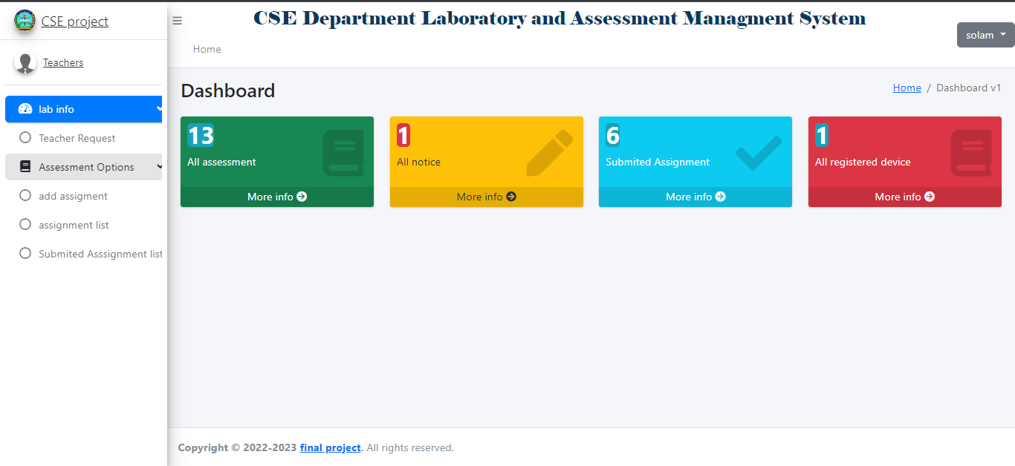

**Figure4.10 Teacher Homepage**

**4.2.3.3 add assignment**

On this page, the teacher add a new assessment for the student. the student is identified from another student by the year, session, student group, and specialization if they are the same year, session, group, and specialization the assessment inserted by the teacher can be displayed in the student’s new assignment section. unless one of the above criteria is not much example specialization is different from the other the assessment is inserted for other specializations.

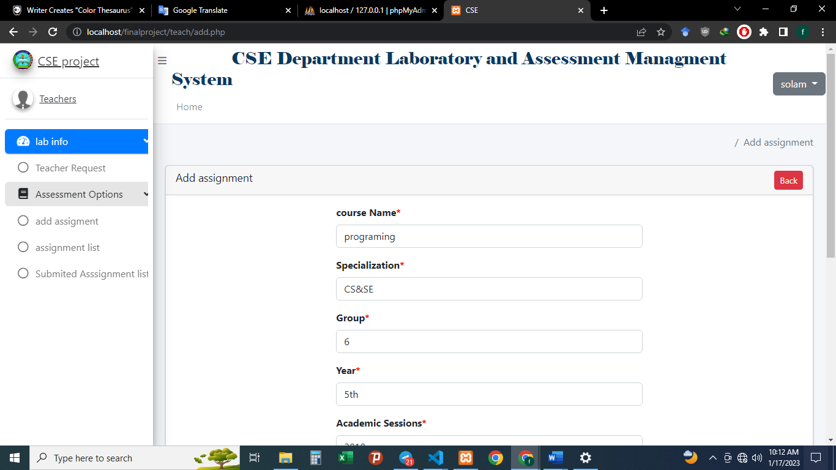

**Figure4.11 Entering assessment page**

**4.2.3.4 Assessment list**

After entering assessment, the teacher can also edit it. After editing the assessment the updated data is stored in the assessment database saved and display.

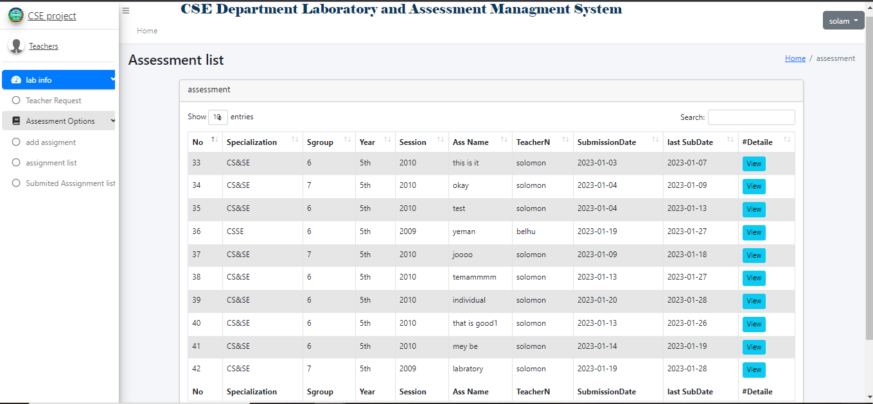

**Figure4.12 assessment list**

**4.2.3.5 Submitted assignment**

For each submitted assignment, the teacher can view the assignment status submitted by the students. And the teacher gives results for the submitted assignment. The percentage of the result given by the teacher is described in the description column that is assignment name.

On this page, there is assignment name, student name who submitted assignment, submitted date download button and assignment content for each course. If there is no assignment uploaded yet it displays not assignment submitted yet.

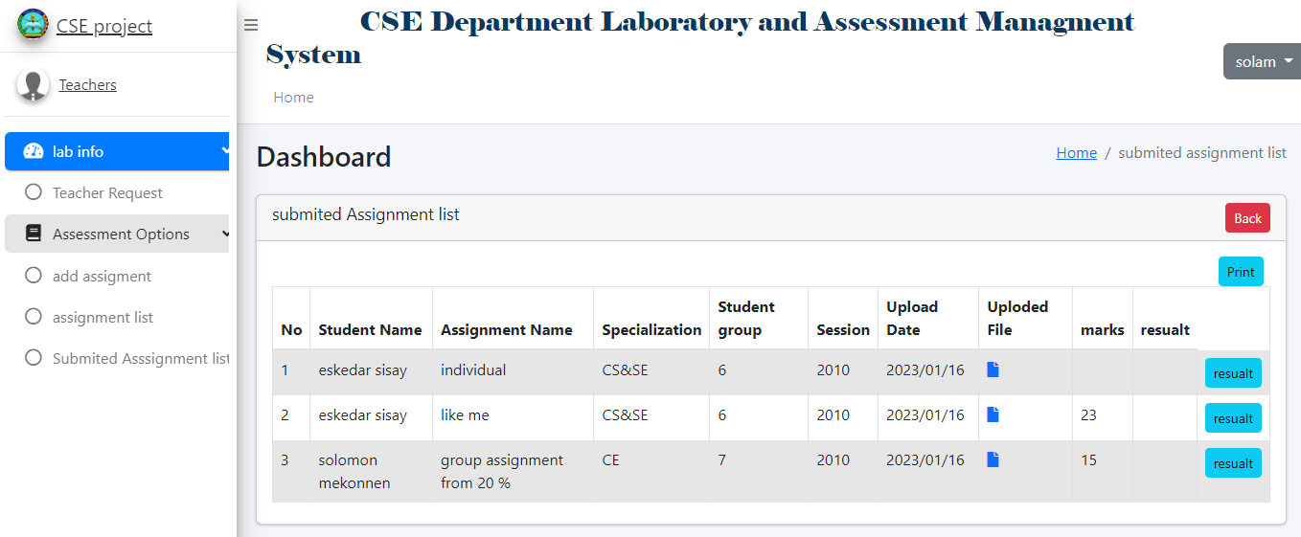

**Figure4.13 Submitted assignment**

**4.2.3.6 Request**

On this Teacher request page, there is the device id, approve status, issue date, and return date that control the device borrowed status. If there is no sending request to the lab assistant to borrow the device the page displays there is no pending request.

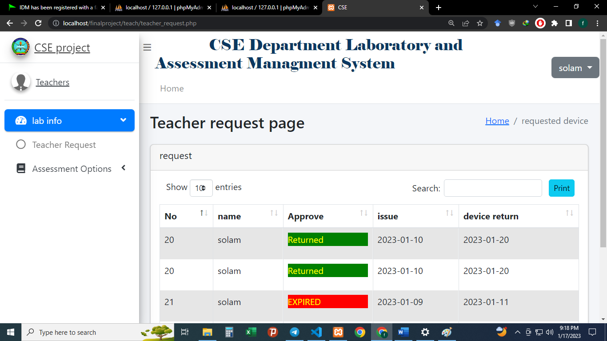

**Figure4.14 teacher request status**

**4.2.3.7 Teachers Change password**

This page helps teachers to create their own passwords. Before you change your password you will need to have your current password given by the admin**.**



**Figure4.15 teachers Change password page**

##### 4.2.4 laboratory assistant page

**4.2.4.1 Login**

Each assistant in the department is assigned a unique email and password by the administrator. The teacher may change the password later.



**Figure4.16 lab assistant login page**

**4.2.4.2 Homepage**

After successful login, the lab assistant presented a Dashboard with their main sections, add the device into the system, device information, device return date expired information, student request, teacher Request, update device, delete device change password. on this page, the user can view the number of all activities on the dashboard.

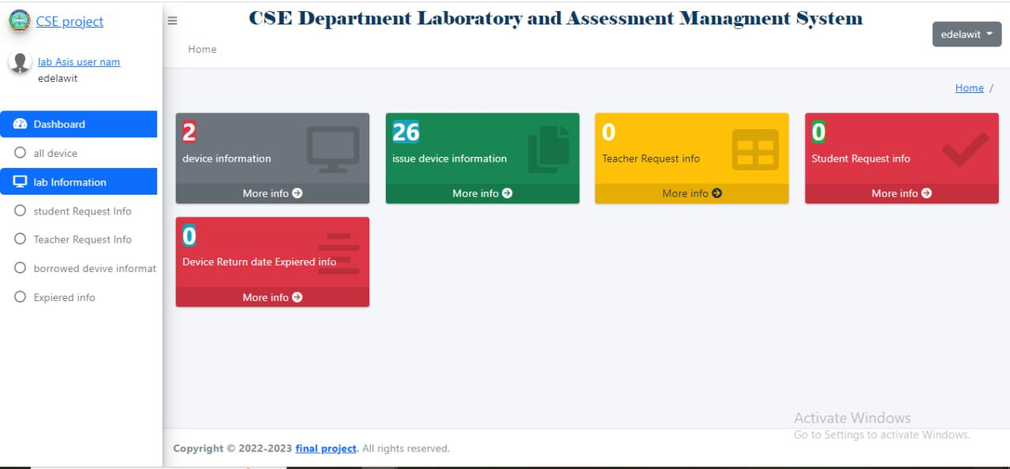

**Figure4.17 lab assistant home page**

**4.2.4.3 device register page**

On this page, the lab assistant register a device using a popup modal when the modal is popup on the page device registered list is visible in a tabular form. The user can delete, update, and view the device status on this page. lab assistance can control device status on this page when the device status is not available and the device quantity is 0 lab assistant doesn’t approve the request.

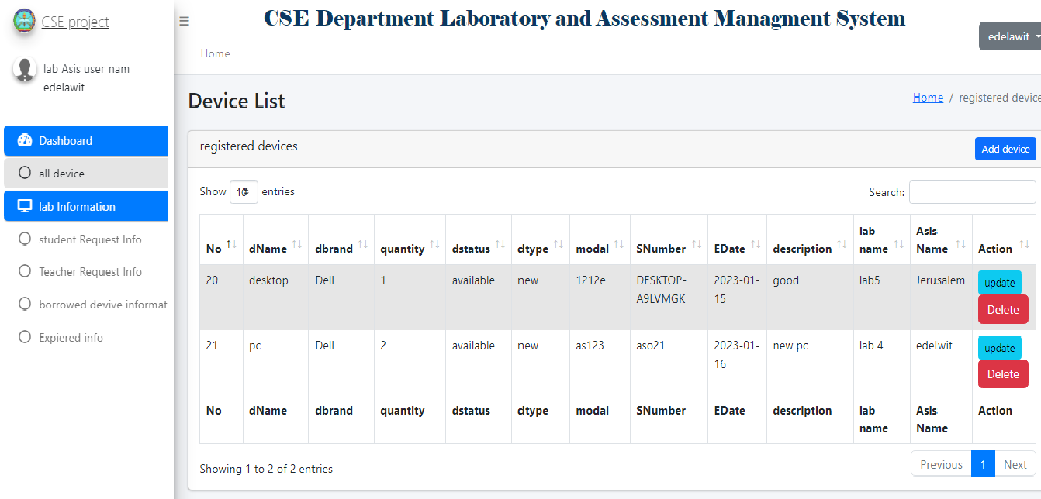

**Figure4.18 Device List page**

**4.2.4.4 device register page**

On this page, the lab assistant Updates a device using Did.

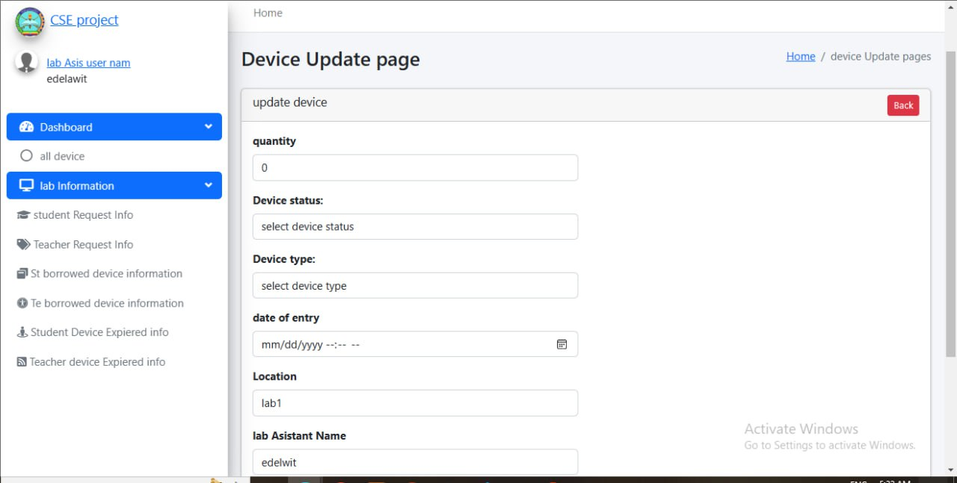

**Figure4.19 lab device update page**

**4.2.4.5 Student Request device page**

On this page, the lab assistant can approve student requests if the device status is available using a popup modal when the modal is a popup on the page device registered list is visible in a tabular form. The lab assistant also checks students’ Bache or year because students can borrow from the lab that assigns that Bache.

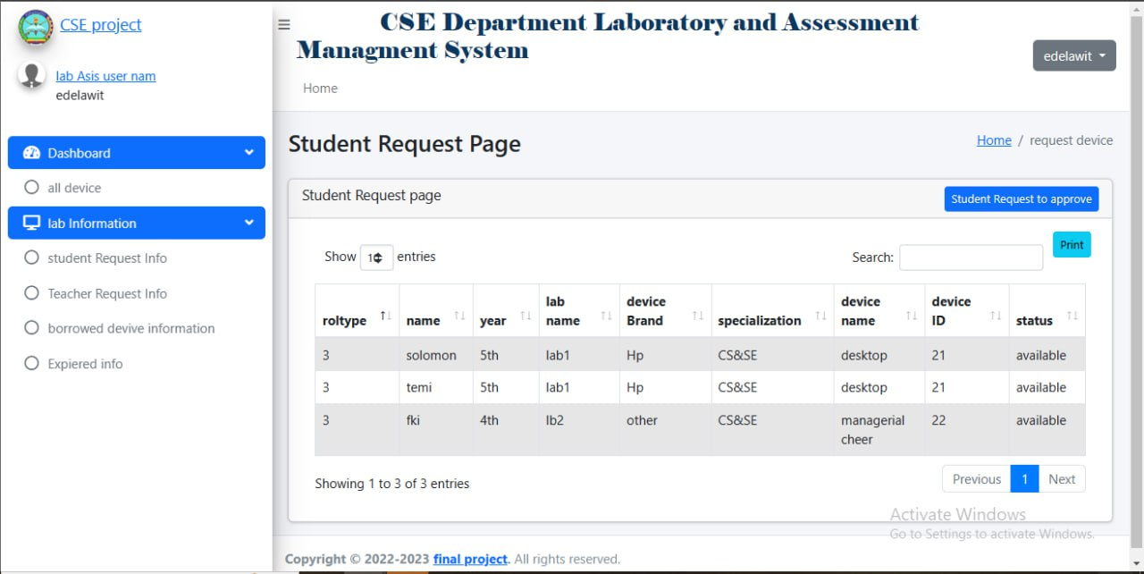

**Figure4.20 In the lab assistant student Request page**

**4.2.4.6 Teachers Request device page**

On this page, the lab assistant can approve the Teacher’s requests if the device status is available using a popup modal when the modal is a popup on the page device registered list is visible in a tabular form.

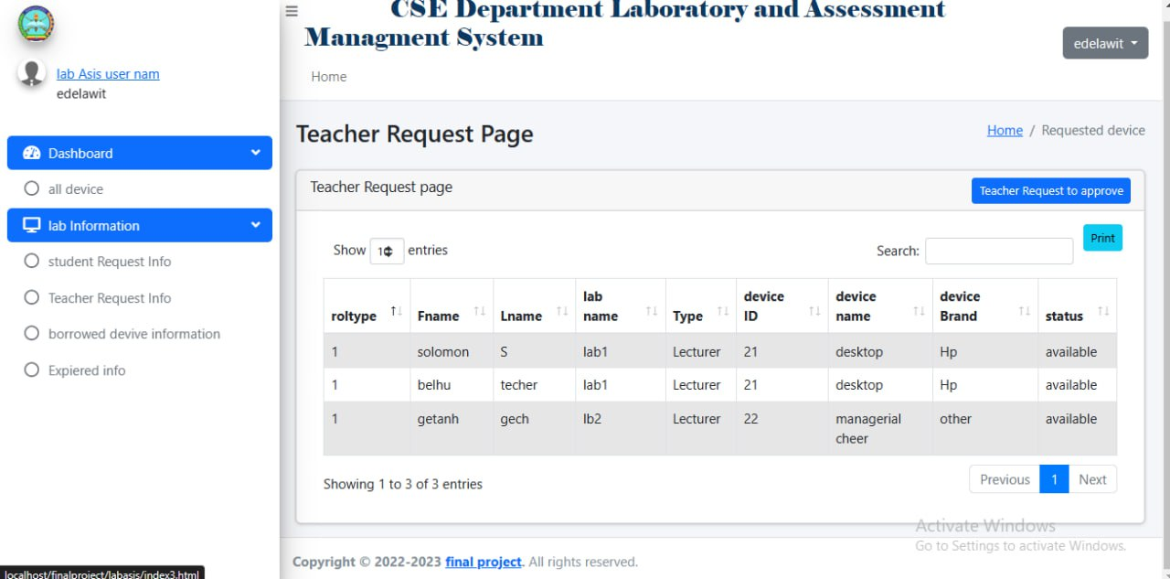

**Figure4.21 On lab assistant Teacher Request page**

**4.2.4.7 Students borrowed device page**

On this page, the lab assistant can return the device if the student went to return the device before the return date is reached. using a device ID and student role number when the device id and role are different the device is not returned. the returned device is removed from this page.

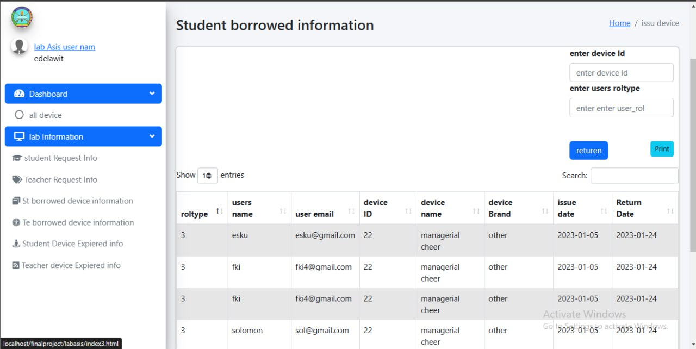

**Figure4.22 In lab assistant student Borrowed device information page**

**4.2.4.8 Teachers borrowed device page**

On this page, the lab assistant can return the device if the teacher went to return the device before the return date is reached. using a device ID and teacher role number when the device id and role are different the device is not returned. the returned device is removed from this page.



**Figure4.23 In lab assistant Teacher Borrowed device information page**

**4.2.4.9 Teachers borrowed device expired page**

On this page, the lab assistant can view and return the device if the teacher went to return the device after the return date is reached which is Expired. using a device ID and teacher role number when the device id and role are different the device is not returned. the returned device is removed from this page.

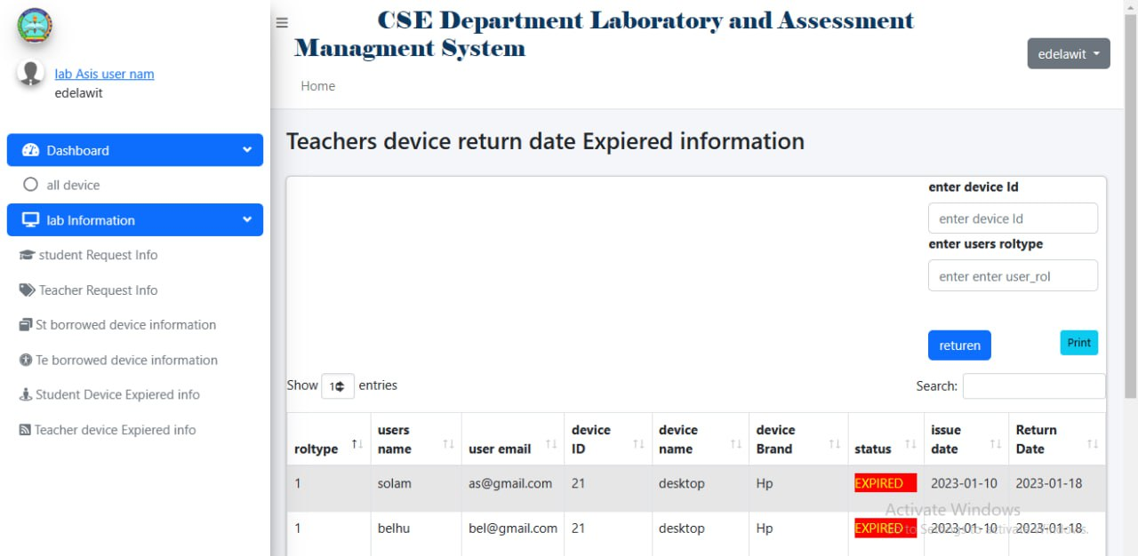

**Figure4.24 In lab assistant Teacher Expired device information page**

**4.2.4.10 students borrowed device Expired page**

On this page, the lab assistant can view and return the device if the teacher went to return the device after the return date is reached which is Expired. using a device ID and teacher role number when the device id and role are different the device is not returned. the returned device is removed from this page.

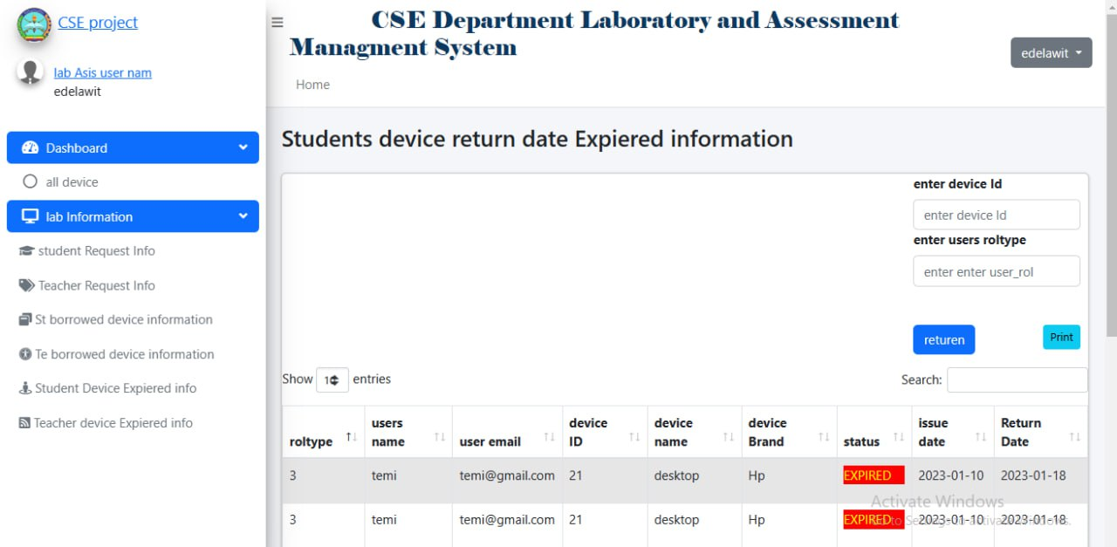

**Figure4.25 In lab assistant student Expired device information page**

**4.2.4.11 Lab assistant Change password**

This page helps teachers to create their own passwords. Before you change your password you will need to have your current password given by the admin**.**



**Figure4.24 In the lab assistant Password change page**